Instructions

Task Intro
👋 Welcome!
We’re currently developing an AI assistant 🤖 that helps you complete tasks through a web browser. We need your detailed feedback to help develop a more helpful and accurate AI assistant.
🚨Important Note: LLM usage is strictly prohibited on tasks. Any usage detected will result in termination from the project.

🎯 Here’s what you’ll be doing: | ✅ How to Evaluate:
You will see a user's request (prompt), along with two attempts to solve it (Response A and Response B). We need your expert eye to help us figure out which one does a better job through a detailed, side-by-side comparison of the Responses. | To make your evaluation as useful as possible, please move beyond a simple "gut feeling." Instead, use the specific criteria provided to conduct a fair and objective evaluation. This structured approach is the most reliable way for us to understand what makes a response truly successful.
⚠️KEY WARNING: YOUR RATING JUSTIFICATIONS NEED TO BE IN VERY SPECIFIC FORMATS FOR EACH RATING:
- Completion: Identify the prompt, the main goal of the request, and any sub requests. Then, summarize your investigation+rating on completion of each request.
- Factual accuracy: List all factual claims, use the justification builder for each, then summarize the final verdict.
- AI Performance: Focus on the key areas to observe (Navigation, Interaction, Efficiency, and Output Quality).
- Best Response: Use the template summarizing all individual scores + the SxS verdict, followed by a justification referencing the ratings and key tiebreakers.

🔧 Tools
On the right-hand side of the UI, there are various tools you can make use of:
- ℹ️ Click “Show Instructions” to see detailed instructions any time.
- ✏️ Take Notes: These can help you compile effective reasoning behind your rating. Strive to distinguish between main claims and secondary constraints.
- ⚖️ Justification Builder: You may use this to help when performing fact-checking. It is essential to use
- 💬 Feedback: We'd love to hear your thoughts on this task, so please share any feedback!

Check the Instructions
Take Notes
Build your Justification
Give your Feedback
The success tools workflow is as follows:

Instructions
💡 Top Tip! It can be helpful to take notes during your evaluation! You can use our handy note-taking feature.
⭐ Use the guides provided in these instructions to help you.

Overview
🕵️ Your Role: Be a detective. Use the checklist to find the specific evidence for why one response is better, and report your findings.
To build your case, you will gather evidence by evaluating each response on these four key areas:
- ✅ Task Completion: How completely did the AI address the entirety of the user’s request?
- 🎯 Factual Accuracy: How accurate are any facts or information provided?
- ⚙️ AI Performance: How would you rate the skill, quality and efficiency of the AI?
- 🏆 Best Response: After weighing all the evidence, this is your final conclusion.
- 🚨 Reporting Roadblocks: You will also be asked to report any technical problems that blocked or interfered with your investigation.

Be a Detective
Identify + Research + Describe = Conclusion
Identify
Task Completion
Research
Factual Accuracy
Describe
AI Performance

Reporting Roadblocks

Judge
Best Response

Question 1: Was completion of the task blocked by any unusual errors or crashes?
If the agent faced any unusual errors or crashes during the task, mark the answer as “Yes” and select the appropriate reason from the dropdown. If no option matches the correct reason, select the “Other issue” option and provide a justification explaining the issues that occurred during task completion.
Otherwise, simply select “No” and move to the next question.

Question 2: Task Completion
Your goal here is to determine how well the AI completed every part of the user's request. A successful response doesn't just get the main idea right; it follows all the specific rules and instructions.
Follow these three steps to build your case and make an accurate rating:

Step 1: 🎯Analyze the Prompt
Before looking at the responses, become an expert on the user's request. A single missed detail can change the entire case!
- Identify the Main Goal: What is the user trying to achieve?
- List all Sub-requests: What are the specific constraints, rules, or secondary tasks mentioned? (e.g., specific location, date, price, website, etc.)
Use this template to help organize your thoughts:
User’s Main Goal: (e.g., "Find and compare vacation rentals.")
Sub-requests:
  - (e.g., "Must be in Scottsdale")
  - (e.g., "Must be for a group of 4")
  - (e.g., "Must provide multiple options")
Prompt Main Goal
Prompt Sub-Requests

User Request

Step 2: ⭐Select your Rating
Now, use your "Case File" from Step 1 as a checklist. For each response (A and B), check if it met the Main Goal and every single Sub-request.
- For a "Fully Complete" (5/5) rating: Addressed all the parts of the request, including useful unspoken details)e.g., providing multiple options when asked for “a few”)
- For a "Mostly Complete" (4/5) rating: Addressed the main goal of the request but missed a minor subtask or detail. But it didn’t affect the main goal of the task.
- For a "Partially Complete" (3/5): Addressed a significant part of the request but failed to deliver on the main goal or missed secondary goals.
- For a “Minimally Complete” (2/5): Attempted the task but failed to address the main request, providing only tangential or minimally useful information.
- For a “Not at all complete” (1/5): The task is completely failure. It doesn’t contain any useful information.
Use this template to help organize your thoughts:
For each Response:
  - Main Goal Fulfilled? [Yes/No]
  - Sub-request 1: [Yes/No]
  - Sub-request 2: [Yes/No]
  - Sub-request 3: [Yes/No]
  - Final Rating: [Rating]
  - Justification: [Briefly explain how you came to your conclusion]
Ask yourself: Does the user want it this way, or did the agent respond outside the boundaries?

User request
Main Goal | Sub-request 1 | Sub-request 2 | Sub-request 3 | Useful additional | Task Completion
Yes | Yes | Yes | Yes | Yes | Fully
Yes | Yes | Yes | No | No | Mostly
Yes | No | No | No | No | Partially
No | Yes | Yes | Yes | Yes | Partially
No | No | No | Yes | Yes | Minimally
No | No | No | No | No | Not at all
Step 3: ✍️ Write Your Justification
Your justification is your final report. It’s the most valuable part of your investigation because it explains the evidence behind your rating, and is your best ally for highlighting your findings and clarifying any possible confusion when the data is very similar, but it puts the user at risk.
This step is super important to us! Use the information you gathered in the steps above to be specific.

💡 Example of a Good Justification
Prompt: Find me a few VRBO or AirBnb options in Scottsdale for the week of Valentine's Day for a group of 4.
Case File:
- Main Goal: Find and compare vacation rentals.
- Sub-requests: Must be in Scottsdale, must be for a group of 4, must provide multiple ("a few") options.
Investigation Notes:
- Response A met the main goal and all 3 sub-requests, earning a 5/5 (Fully Complete).
  - Justification: The response successfully met the main goal and all three sub-requests. It provided three relevant options that matched every constraint in the prompt, making it a perfect and useful answer.
- Response B met the main goal but failed all 3 sub-requests, earning a 2/5 (Minimally Complete).
  - Justification: While it found a vacation rental (fulfilling the main goal at a basic level), it failed on all three critical sub-requests. The location was wrong (Phoenix instead of Scottsdale), the group size was incorrect (2 people instead of 4), and it only provided a single option.
Final Verdict: "I chose Response A as much better. The primary and deciding factor was Task Completion. Response A successfully addressed every part of the prompt; all the results are located in Scottsdale, for a group of 4, and have multiple options, as can be verified in the sources. In stark contrast, Response B failed on every single sub-request, making it completely irrelevant to the user's needs because the results are from Phoenix. This made Response A a useful and actionable answer, while Response B was unhelpful."
Note that the structure of the justification clearly identifies the reason why response A complies with the restrictions, while response B clearly explains why it is not useful.

Question 3: Factual Accuracy
NOTE: You can use the handy Justification Builder found in the side toolbar to help structure your justification.

⚖️ What is a Claim? (Objective vs. Subjective)
A claim is any statement in the response that can be checked for accuracy. It can be proven either true or false. You should only fact-check objective claims.
- ✅ Objective: A statement that can be proven true or false with evidence (facts, data, etc.).
  - Example: "The Eiffel Tower is in Paris."
- ❌ Subjective: A statement of opinion, belief, or personal feeling. It cannot be proven true or false.
  - Example: "The Eiffel Tower is beautiful."
Note: Be careful, expressions such as “always,” “definitely,” and “without a doubt” are often linked to biased reasoning. In these cases, it will be necessary to rely on evidence from sources to determine whether it can be objectively verified.
🎬 Example: How to Identify Claims
Be thorough! Break down the response into individual, numbered claims. Don't combine multiple ideas into a single claim.
Prompt: What is Haku's true identity in Spirited Away?
Response: Haku's true identity is a fascinating part of the Spirited Away story! In the film, Haku is a mysterious boy who works at the bathhouse and helps Chihiro navigate the spirit world. However, it's later revealed that Haku is actually the spirit of the Kohaku River. He was once a powerful river spirit, but after being injured by humans, he lost his memory and ended up working for Yubaba. When Chihiro incorrectly guesses his true identity, Haku is finally able to break free from Yubaba's control and return to his river.
Here's how we'd identify and label the claims:
- Haku's true identity is a fascinating part of the Spirited Away story! (❌ Subjective)
- Haku is a mysterious boy who works at the bathhouse and helps Chihiro navigate the spirit world. (✅ Objective)
- Haku is actually the spirit of the Kohaku River. (✅ Objective)
- He was once a powerful river spirit, but after being injured by humans, he lost his memory and ended up working for Yubaba. (✅ Objective)
- When Chihiro incorrectly guesses his true identity, Haku is finally able to break free... (✅ Objective - and in this case, factually wrong!)

📚 How to Research Claims & Find Reputable Sources
Use reliable sources to verify or refute each objective claim. Don't rely on just one source!
What are Reputable Sources?
- Authority: Is the source a known expert? (e.g., a scientific journal, a respected museum)
- Objectivity: Is the source fair and unbiased?
- Accuracy: Is the source known for being correct?
- Currency: Is the information up-to-date?
👍 Good Examples: Encyclopedias (like Britannica), academic journals, reputable news organizations (like the New York Times, BBC, Reuters), government websites, official company/organization websites.
👎 Less Reliable Examples: Wikipedia or Fandom Wiki (good for starting, not for final proof), personal blogs, social media posts, websites with obvious bias.
Note: In the case of movies, comics, series, and similar. Which blogs are the most respected? Are there interviews with authors and producers? A couple of up-to-date and respected sources can be much better than one blog's opinion. The key is to stay focused on avoiding making value judgments in the justification, but rather sticking to the evidence from the sources.
Stay focused: In many cases, it is as simple as confirming that “most viewers like to watch streaming series on weekends in the US” with a statistical link from a reputable source. Note that this does not claim that everyone does so, only that it is true of "viewers of streaming series in the US," not the entire population. This could save a significant amount of research time; the keywords are crucial.

Choose the best option available:
1. Completely accurate: All factual claims are supported by reputable evidence.
2. Mostly Accurate: Contains minor inaccuracies that don’t spoil the overall response.
3. Mixed Accuracy: Contains a significant mix of both accurate and inaccurate information.
4. Mostly Inaccurate: The core information is factually incorrect or misleading.
5. Completely Inaccurate: The entire response is based on false information.
6. Cannot Confidentially Assess: Unable to understand, identify, or properly assess the claims in this response.
✍️ Justification Template
Use this if you don’t use the Justification Builder.
Objective Claims Identified:
- [Claim 1 text...]
- [Claim 2 text...]
- [And so on...]

Claim 1: [Rating Given] Justification: [Brief explanation of your reasoning, referencing the sources.] Sources: [Source 1 URL] [Source 2 URL]
Claim 2: [Rating Given] Justification: [Brief explanation of your reasoning, referencing the sources.] Sources: [Source 1 URL] [Source 2 URL]

Final Justification: [Overall summary of the response's accuracy.]

*Note: If verification links are broken or lead to 404 errors, refer to the FAQ Section: Broken Links for specific grading penalties. If the response get stuck on a CAPTCHA also refer to the FAQ.

Question 4. AI Performance
This question is different from the others. We're not just looking at the final answer. We're judging the skill and intelligence the AI showed along the way. Think of yourself as a performance reviewer watching the AI work.
The key question is: Did the AI achieve the goal gracefully and efficiently, or did it stumble and get lucky?

✅ Key Areas to Observe
When evaluating performance, keep an eye on these four behaviors:
- 🗺️ Navigation: Was the path logical and direct, or did it meander to irrelevant pages?
- 🖱️ Interaction: Did it click the correct buttons and links precisely, or did it struggle and make mistakes?
- ⏱️ Efficiency: Were there wasted steps, loops, or unnecessary actions?
- 🧹 Output Quality: Is the final scraped text clean and well-formatted, or messy and filled with junk?

⭐ How to Apply the 5-Point Scale
Here’s a breakdown of what each rating means, with concrete examples. Click on each rating to see the details.
(5) Excellent (Expert & Optimal)
- Ask yourself: Was this a flawless, expert-level performance?
- Look for: Direct navigation, precise clicks, no wasted steps, and a clean final output. The AI behaved exactly as a skilled human would.
(4) Good (Effective but with minor flaws)
- Ask yourself: Was it almost perfect, but with one small mistake?
- Look for: A solid and logical process that had one minor, observable flaw. For example, it took one extra, unnecessary click, or the final output had a tiny formatting error.
(3) Acceptable (Clumsy but Functional)
- Ask yourself: Did it get the job done, but in a clumsy or inefficient way? This is the "it works, but..." category.
- Look for: An inefficient path (e.g., going to the Help page before finding the Contact page), clumsy actions (e.g., clicking an ad before correcting itself), or a messy but still usable final output.
(2) Poor (Illogical & Flawed)
- Ask yourself: Was the process itself a failure, even if it got a tiny bit of the answer right?
- Look for: Illogical steps where the AI seems confused or lost. It might struggle repeatedly to find the right button, or it only succeeded by chance, not by skill.
(1) Unacceptable (Broken or Nonsensical)
- Ask yourself: Did the AI completely fail to perform the actions required?
- Look for: Getting stuck on a page, being caught in a loop, timing out, or being fundamentally incapable of interacting with the website correctly.
- Important: If the response gets stuck on a CAPTCHA or security check it is always rated as Unacceptable (1/5) performance. See the FAQ: CAPTCHA Handling for a visual example and more details.

✍️ How to Write a Good Justification
Your justification should explain the specific actions that led to your rating. Reference the key areas of observation (Navigation, Interaction, Efficiency, and Output Quality).
Use this template to help structure your thoughts:
Response A: [Rating] Justification: [Brief explanation of your reasoning]
Response B: [Rating] Justification: [Brief explanation of your reasoning]
Best Response: (e.g., "Response A, significantly.") Justification:

Best Response Guide
🕵️ You've investigated both responses and collected your evidence by answering the detailed questions. Now it's time to make your final call and write your report (rationale).

⚖️ How to Compare and Decide
First, review your scores for each response side-by-side to identify the key differences.
Question | Your Score for A | Your Score for B
Task Completion | [e.g., 5] | [e.g., 3]
Factual Accuracy | [e.g., 5] | [e.g., 5]
AI Performance | [e.g., 4] | [e.g., 5]

The Golden Rules for Making Your Decision
- 👑 Correctness is King: Task Completion and Factual Accuracy are almost always more important than AI Performance. A clumsy response that gets the right answer is better than a graceful response that gets the wrong answer.
Example: *"Response A fully completed the task by adhering to all requests. In contrast, Response B failed on a key sub-request, making it significantly less useful." *
- 👔 Performance is the Tie-Breaker: If both responses are correct and complete, use AI Performance to decide which is "slightly better." The more efficient and skillful agent wins.
Example: *"While both responses were fully accurate, Response A's skillful and efficient navigation made it a higher-quality response overall." *

✍️ How to Write Your Final Report (Rationale)
Your written justification is critical! It explains the evidence behind your decision. Use the template below to structure your thoughts and be specific.
Use this template in the justification box:
Response A Scores:
- Task Completion: [Your Rating]
- Factual Accuracy: [Your Rating]
- AI Performance: [Your Rating]
Response B Scores:
- Task Completion: [Your Rating]
- Factual Accuracy: [Your Rating]
- AI Performance: [Your Rating]
Final Verdict: [e.g., Response A is much better.]
Justification: [Write the reason for your final recommendation, referencing the scores and Golden Rules above. Explain the most important difference that led to your choice.]
Reporting Roadblocks

You will also be asked to report any technical problems that blocked or interfered with your investigation.

FAQ

FAQ + Other resources

* [NEW] Frequently Asked Questions (FAQ): Check here first for guidance on things like edge cases, Jibble, CAPTCHAs, broken links, target AHT, etc. FAQs Computer Use Eval

Justification with limited/restricted information

On certain occasions, the agent will make statements that do not necessarily appear to be inaccurate, such as statements related to user elements that may not be accessible for public investigation. In that case, instead of simply assuming that they cannot be verified, the correct question will be, which elements provide certainty and can be verified? e.g., sometimes agents respond with “Wednesday” instead of “Thursday”, or the text states “in the morning” when the appointment is actually “in the afternoon.”

This can be verified by checking that the time slot, day of the week, and sender's name are consistent. Evidence can include a link to World Time Buddy and/or an online calendar. Remember, in some cases, it will be important to focus on what we can verify, rather than what we lack evidence for, and this is made clear through the justification.

Justification Structure example:

“The agent has access to a calendar and schedule that is not public; however, there is no evidence of any inconsistencies, such as the day of the week, time, and sender.”

Time-dependent Responses:
The timestamp of the resources and responses mentioned is the key drive here; do you have some insight into what timeline for reference is used? On the other hand, each batch could have a certain timeline reference for the client, and this must be clarified.

Stay focused:
Be sure not to assume that the structure of the response actually refers to a matter related to a specific period. For example, sometimes references are passing and are not really a reference to be investigated.

“Get the price of the blue vase we bought on Saturday” is not the same as “Search for more blue vases at a lower price than on Saturday.”

In the first case, it is sufficient to obtain a reference price for the same item on the current date. In the second case, a comparison must be made between a previous price and the current price. In either case, it is sufficient to obtain a price reference; a specific amount is not necessary, but rather whether the item costs less.

Flight/Hotel history research tools:
Can you use tools like this, or similar ones, to track the history of certain flight and hotel prices? In such cases, a clear reference to the source is key to staying objective; it isn´t an assumption.

Task Examples + Format

Format
Prompt
Pre-provided static input - text

[Potential Inclusion] What makes a good response?
Text input field

Response Display
Pre-provided static input - text + image

Per response rating

Was completion blocked by any unusual errors or crashes?
Yes/No Selection
If yes, multiselect option + justification

Task Completion
1-5 Scale + Justification

Factual Accuracy
1-5 Scale w/ “Cannot Assess” Option + Justification

AI Performance
1-5 Scale + Justification

SxS Rating
7 point likert scale + justification

Sample 1: Multimodal Input
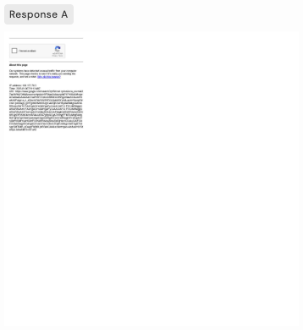
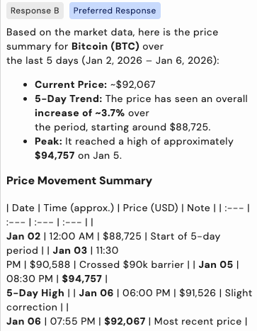
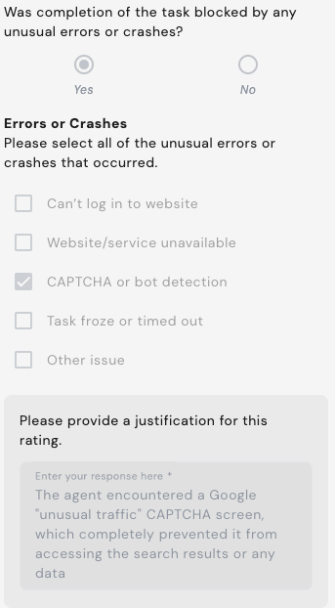
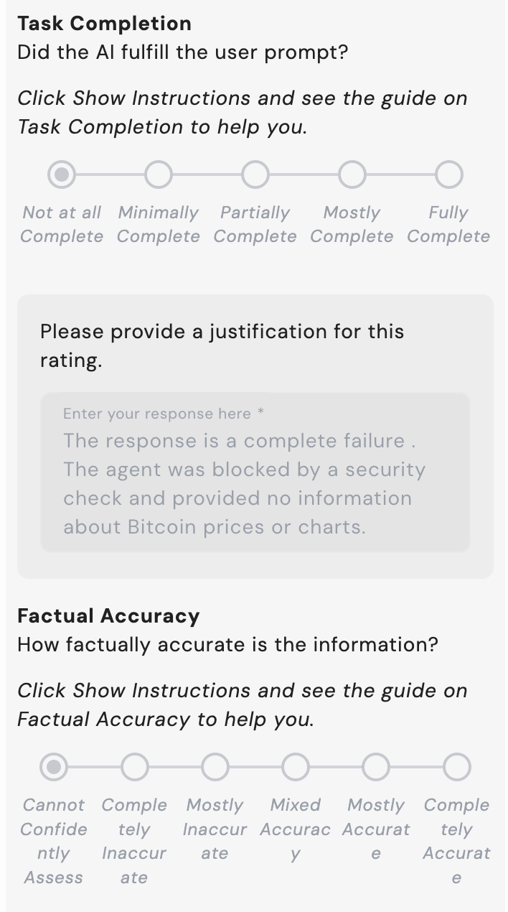
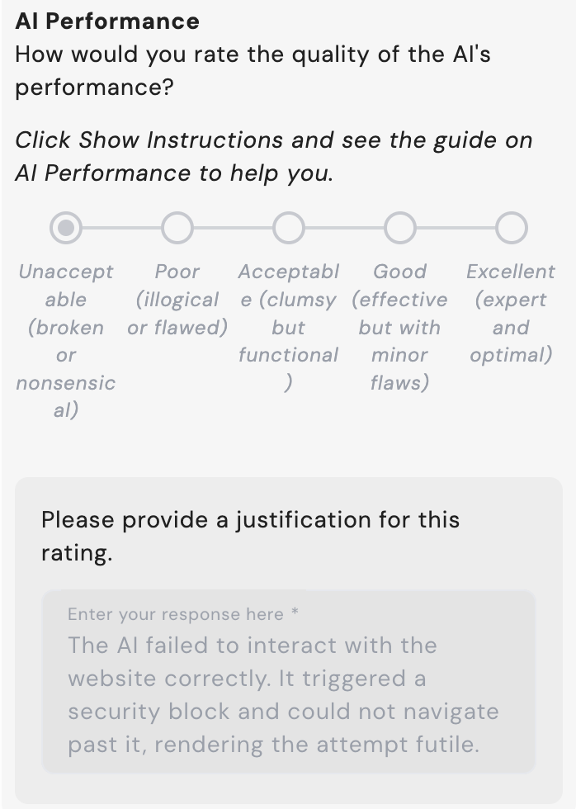
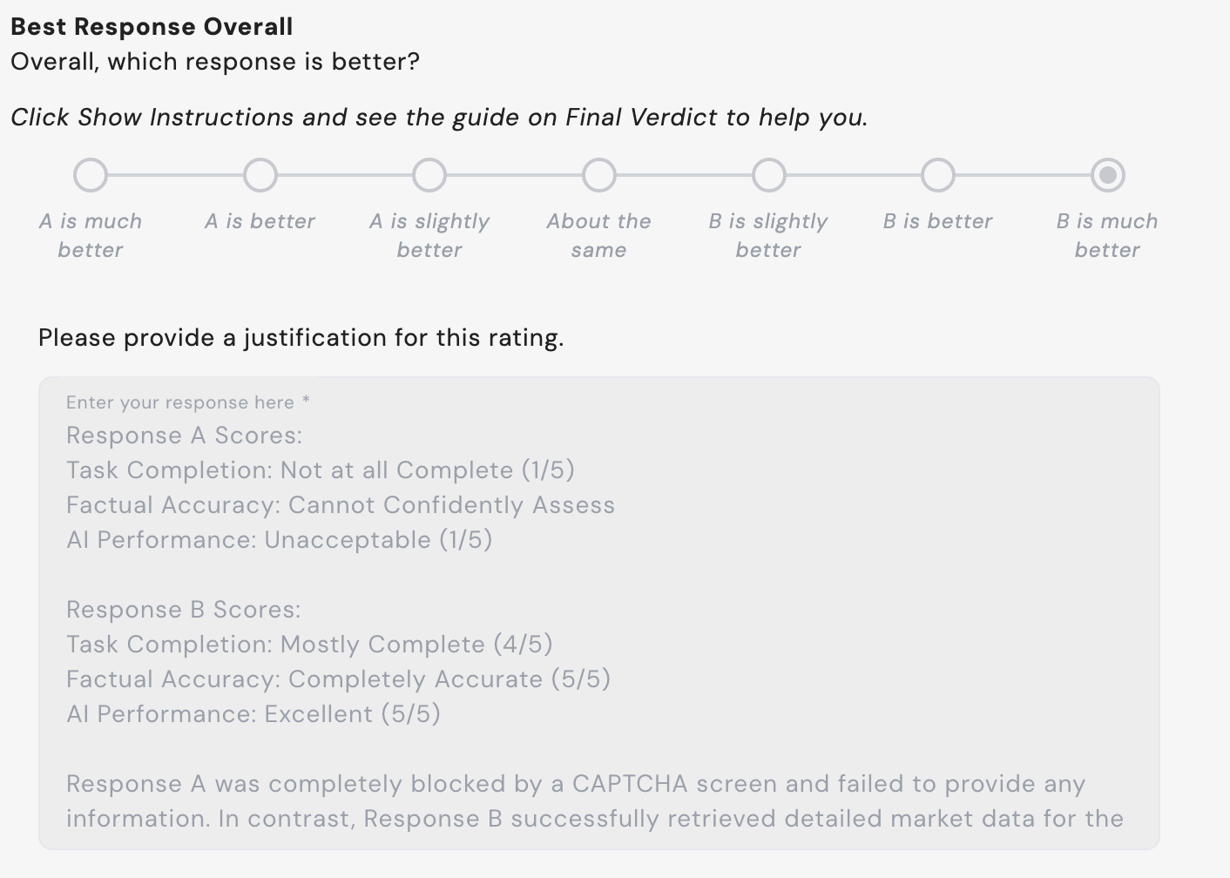

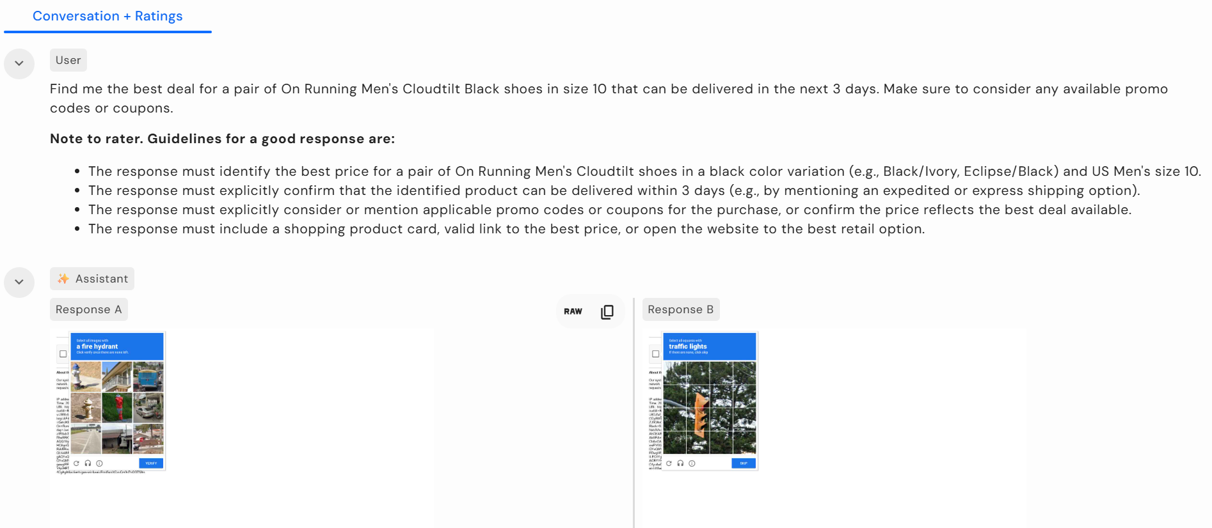
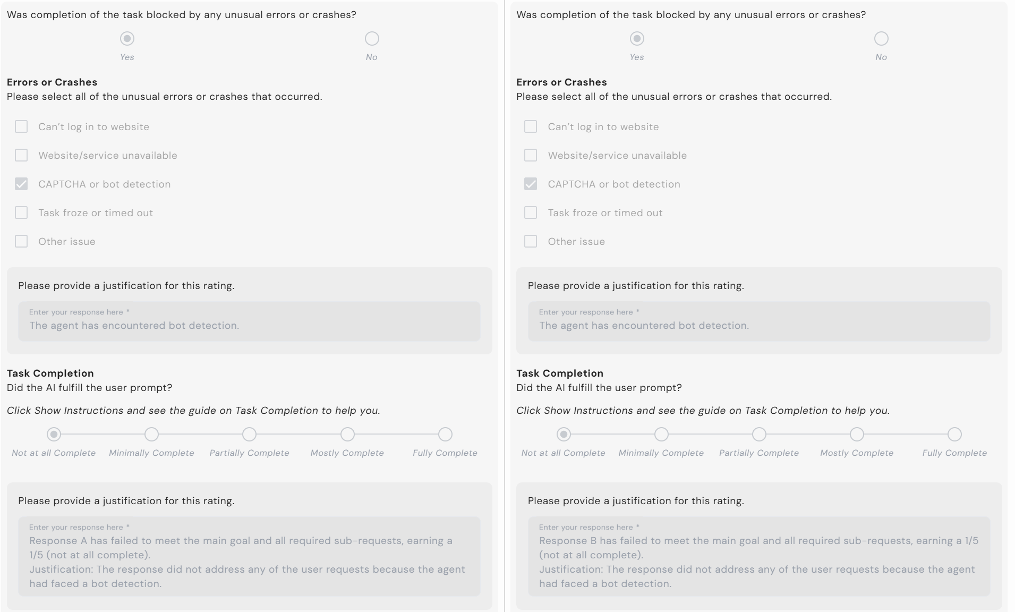
Sample 2: CAPTCHA Failure
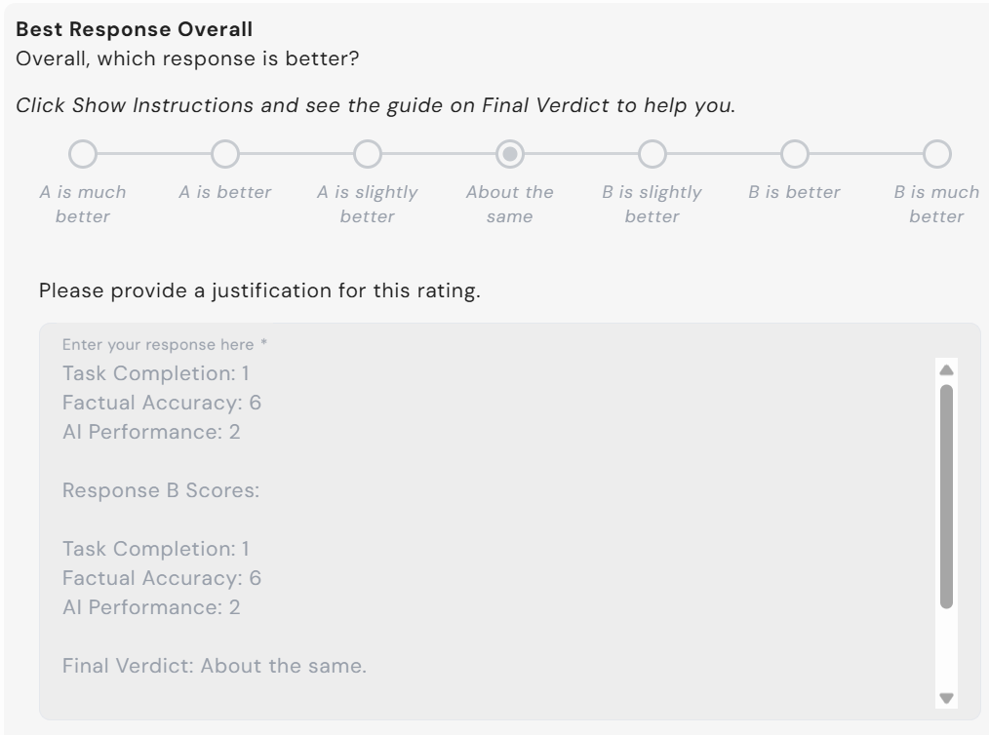
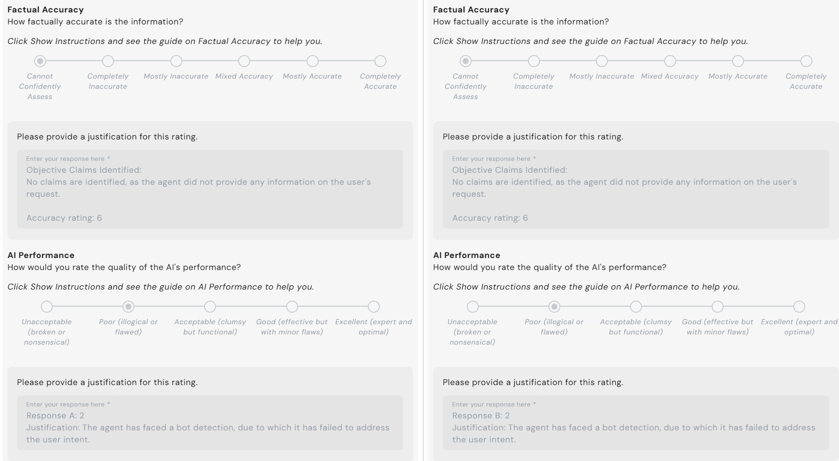

1
1

Please provide a justification for this rating:
Response A Scores:
- Task Completion: 1
- Factual Accuracy: Cannot confidently assess
- AI Performance: 1

Response B Scores:
- Task Completion: 1
- Factual Accuracy: Cannot confidently assess
- AI Performance: 1

Final Verdict: About the same

Justification: Both responses A and B fail to get past the CAPTCHA test. This is unacceptable per the guidelines as the responses completely fail to complete the requested tasks entirely, scoring a 1 for task completion and AI performance. Neither model can be assessed for factual accuracy as no factual claims are made.

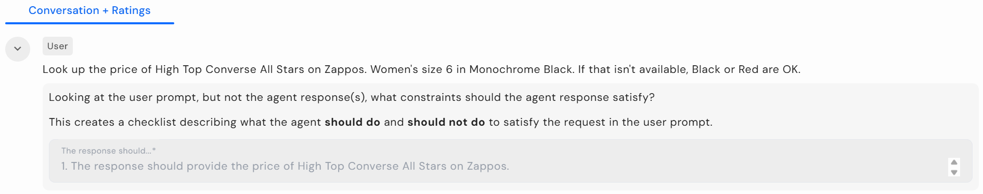
Sample 3: Minor difference in task completion
The response should:
1. The response should provide the price of High Top Converse All Stars on Zappos.
2. The response should provide Women's size 6 in Monochrome Black.
3. The response should provide the Women's size 6 in Black or Red if they are not available in Monochrome Black.
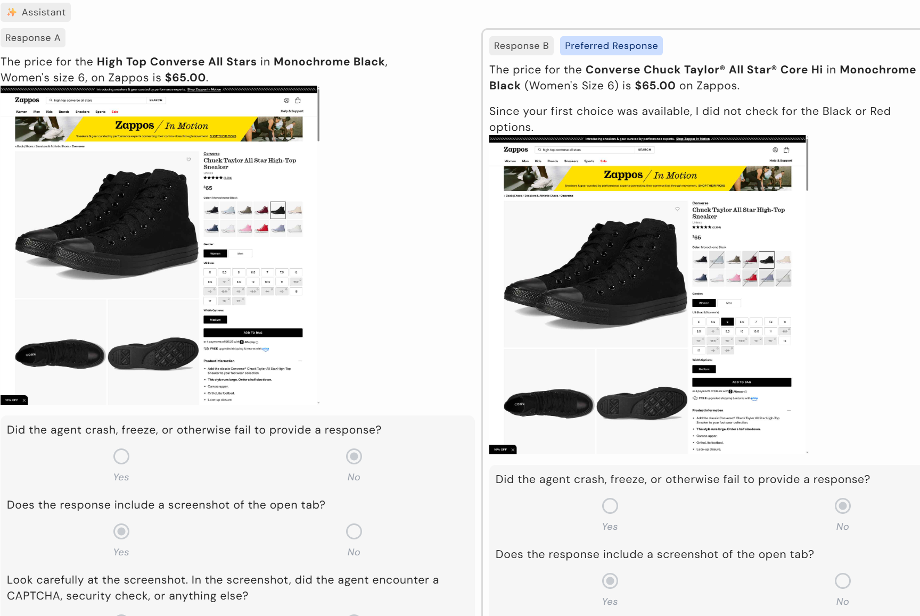
4. The response should provide links/sources where it has found prices
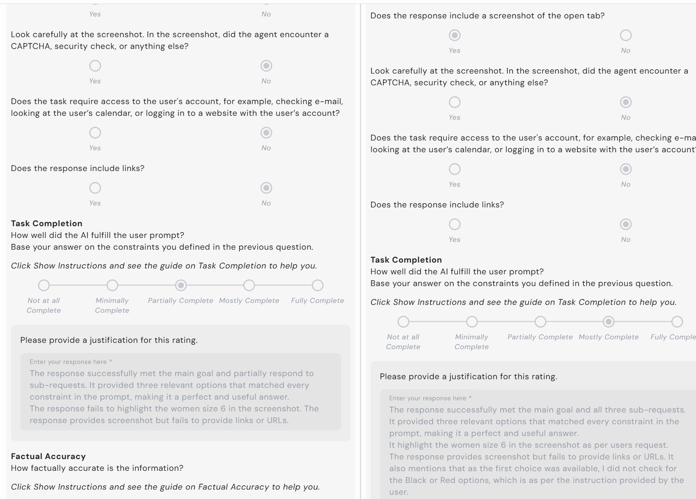

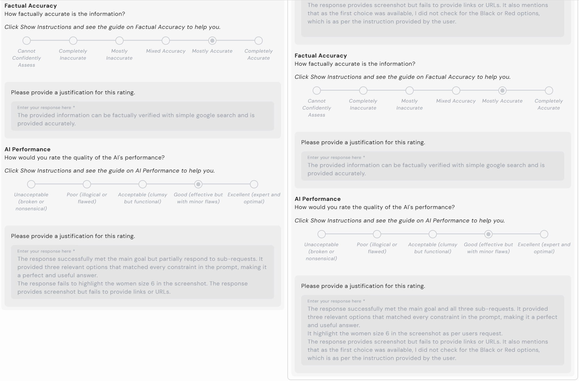

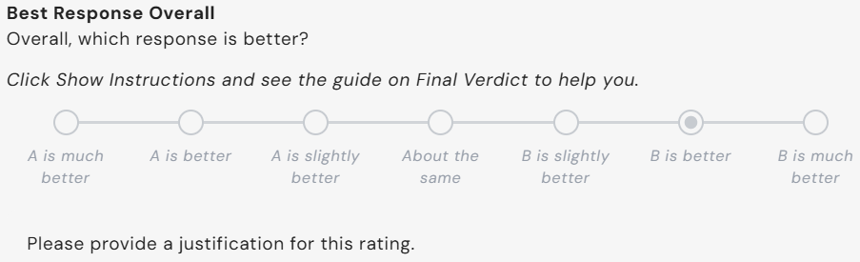
Response A Scores:
Task Completion: 3
Factual Accuracy: 5
AI Performance: 4

Response B Scores:
Task Completion: 4
Factual Accuracy: 5
AI Performance: 4

Final Verdict: B is better than response A

Justification: Response B successfully met the main goal and all three sub-requests. It provided three relevant options that matched every constraint in the prompt, making it a perfect and useful answer. It highlights the women’s size 6 in the screenshot as per users request whereas response A fails to show the correct size in stock. The responses both provide a screenshot but fail to provide links or URLs. Additionally, response B explicitly notes that size 6 is in stock so it didn’t need to search for Black or Red.

